FOR IMMEDIATE RELEASE

SOCIAL MEDIA LINKS:
www.Facebook.com/VegasOutdoorAdventures
Twitter: @LVAdventure
Instagram: @VegasOutdoorAdventures
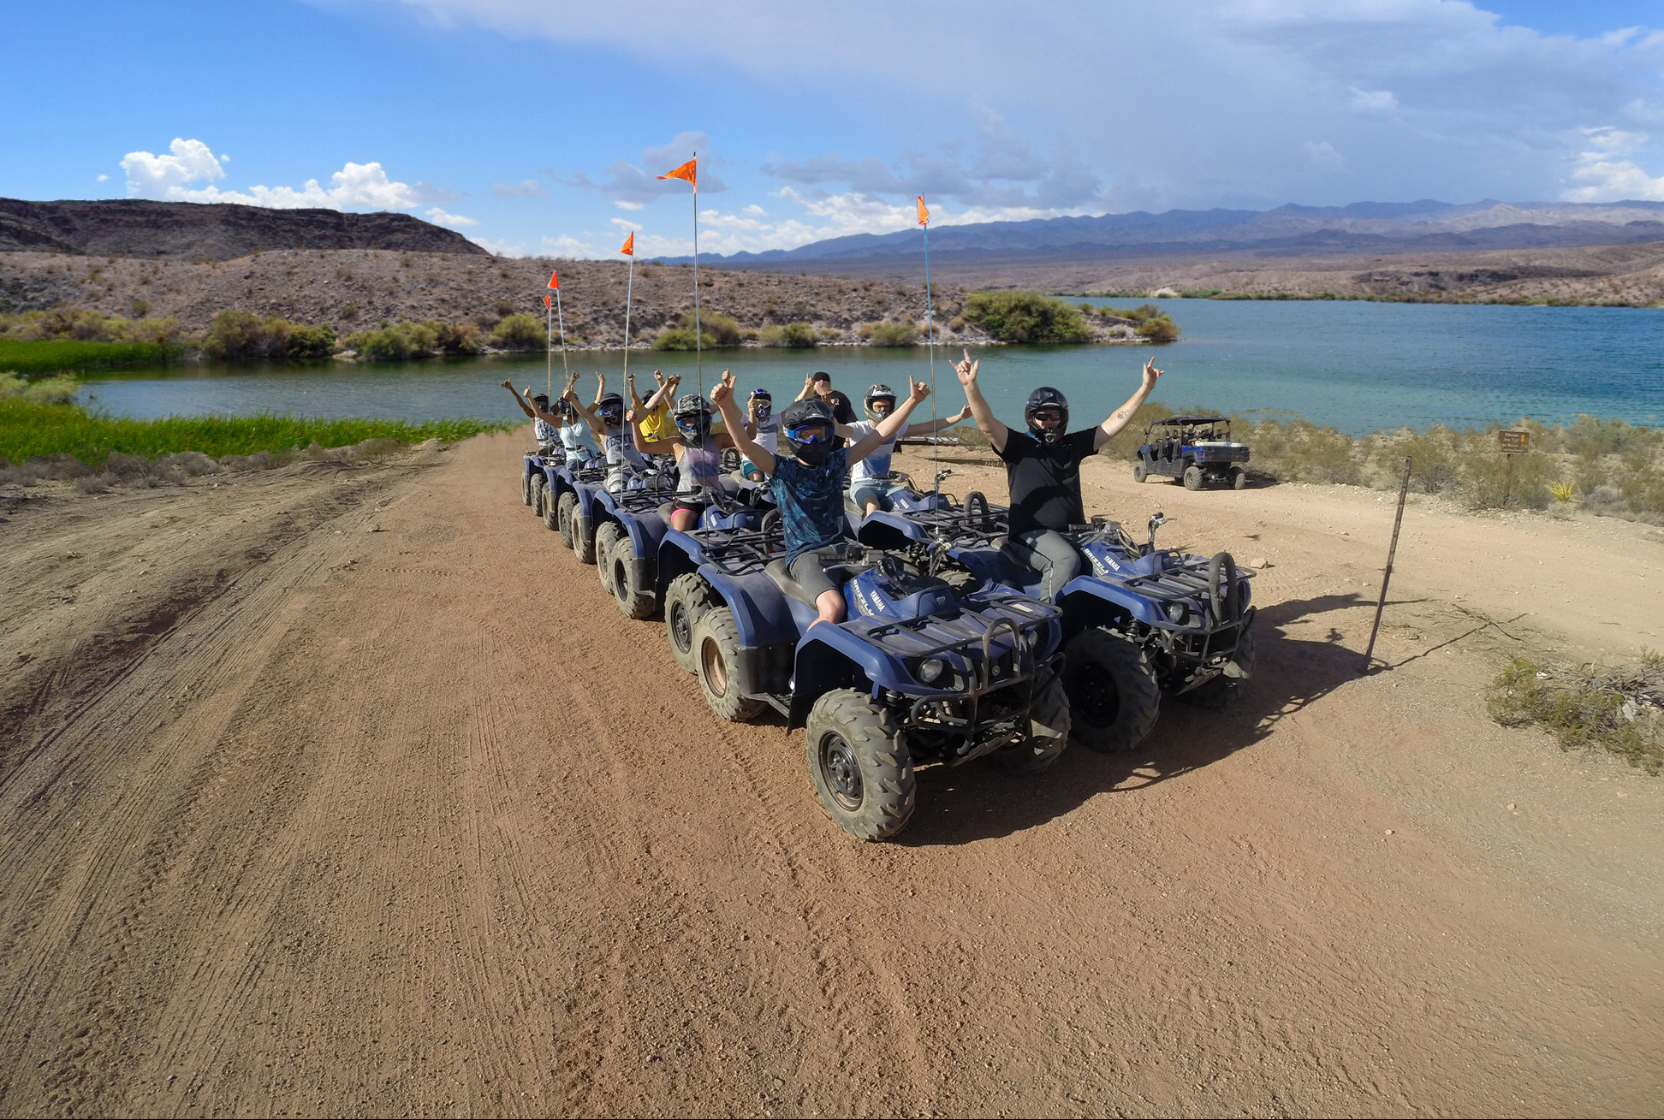
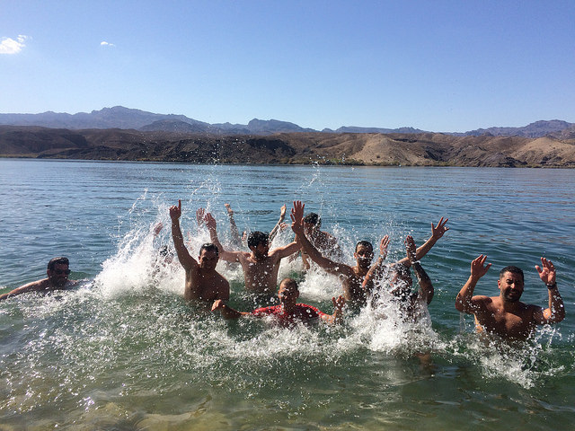

LAS VEGAS OUTDOOR ADVENTURES OFFERS ALL-AMERICAN EXPERIENCES TO ADRENALINE SEEKERS FROM AROUND THE WORLD

Custom tour packages can include any combination of:
- Exclusive ATV, Razor and Jeep tours to the Colorado River
- Outdoor, military-style shooting range—gun options range from handguns to the Barrett .50 Cal—with six custom bunkers to choose from
- Rides in the World’s Longest Monster Truck
- Lunch featuring World-Famous All-American Hamburger—a classic, handmade, half-pound Angus beef all-American burger and fresh-cut fries serviced in the Last Stop Burger Bar

LAS VEGAS (April 2017) – Las Vegas visitors have a new all-encompassing way to make the most of the exhilarating outdoor recreational experiences the desert Southwest offers—Las Vegas Outdoor Adventures (LVOA). This new adventure-tour company offers convenient access to a variety of all-American outdoor experiences, with activities suitable for all ages and areas of interest.

What started as a quick stop restaurant and gas station on U.S. 93 just outside of Boulder City, Nevada—the route that takes travelers from Las Vegas to the Grand Canyon—has grown into a hub for exhilarating adventures. Options include ATV, Razor and Jeep tours to the Colorado River—the only tour through the Lake Mead National Recreation Area of its kind; an outdoor, military-style shooting range and thrill-inducing rides in a monster truck that holds the Guinness World Record for its truly monstrous length.

With numerous packages available, LVOA tours include roundtrip transportation to and from most hotels in Las Vegas, a visit to the Mike O’Callaghan-Pat Tillman Memorial Bridge for a breathtaking view of Hoover Dam, as well as a stick-to-your-ribs meal in the Last Stop Burger Bar featuring the World Famous All-American Hamburger—8-ounces of Angus beef, accompanied by fresh-cut fries and soda.

Visitors can opt for single-activity tours or one that includes multiple experiences all in one day. For birthday parties, bachelor/bachelorette parties and corporate groups, LVOA offers a variety of group-friendly adrenaline activities, which can be capped off with an open bar package at the Last Stop Burger Bar. Outdoors-loving couples even opt to get married on an LVOA tour, and have their nuptials take place on a scenic bluff overlooking the beautiful Colorado River.

Highlights of LVOA activities include:

Exclusive Trail to the Colorado River: LVOA offers the only chance to take a guided scenic motorized tour on the El Dorado Jeep Trail inside the Lake Mead National Recreation Area. Options include ATVs, Polaris Razor 1000, dune buggies, Viking all-terrain vehicles and jeeps. Enjoy the 22-mile guided, roundtrip trail ride through rugged desert scenery, which includes a chance to cool off with a splash in the majestic Colorado River. Tours include helmets, gloves, goggles, lunch and bottled water.

Outdoor Shooting Range: Set outdoors in the expansive Mojave Desert, LVOA’s private range offers a unique “Desert Storm” atmosphere and six military-style bunkers. Guests can shoot automatic machine guns and other specialty weapons, including the Barrett .50 Cal Sniper Rifle, and the largest machine gun in the world: the Browning BMG .50 Cal (“The Deuce”). Now available as an upgrade to any package, the much sought-after Tannerite exploding targets. LVOA’s Range Safety Officers—certified former-military firearms instructors provide guidance for each shooting experience.

Grand Canyon Helicopter Tours: Enjoy a luxurious flight to the Grand Canyon aboard a VIP sightseeing helicopter, outfitted with forward-facing seats and 180 degrees of unrestricted panoramic views. Soar over Hoover Dam, the Mike O’Callaghan-Pat Tillman Memorial Bridge and Black Canyon before descending below the rim of the majestic Grand Canyon. Passengers will be dazzled by the canyon’s monumental, multicolored geologic formations carved over millions of years by the Colorado River. Bus tours to the Grand Canyon are also available.

“Ride and Rifles” Harley-Davidson, Shooting Package: This package combines a shooting experience at Las Vegas Outdoor Adventures’ outdoor shooting range. Passengers are picked up from their Strip hotels and transferred to the Harley-Davidson store just minutes away. From there, they ride over the Mike O’Callaghan-Pat Tillman Memorial Bridge and pause for the spectacular photo op of Hoover Dam. They continue onto the shooting range, just past Boulder City, Nevada, for their shooting experience before embarking on a self-guided tour of the Grand Canyon, Valley of Fire, Red Rock Canyon or any other destination they desire.

“Monster Truck Mayhem”: Add a heart-stopping, shriek-inducing ride-along in the "Sin City Hustler,” which holds the Guinness World Record-winning entry for world's longest monster truck—measuring 9.8 meters—to any adventure.

All activities may be combined with one another to create an unforgettable adventure itinerary. In addition, LVOA offers the chance to add on even more adrenaline to the agenda by combining a shooting experience or guided ATV ride with an American muscle car for 24 hours, a skydiving experience or a ride on a zip line.

New packages and activities will be announced later this spring.

Click here for downloadable high-res photos and broll. Click here more information about Las Vegas Outdoor Adventures, visit, like on Facebook, follow on Twitter or Instagram or call (702) 825-1411.

# # #

